Subject: English Year group: 10
Author(s):
Date | Outline of Teaching Focus | Links to Prior Learning/Interleaving | Links to Key Stage 4/ AOs | Pre, Way Point and End Point Assessments | CORE Links | Opportunities for Development in Cultural Capital | Links to Therapeutic Provision
INTERLEAVE ALL POEMS THROUGHOUT ALL UNITS, LINKED TO THEMES.  FINAL UNIT TO SUMMARISE ALL POEMS/REVISE/CHECK UNDERSTANDING.  ENSURE UNSEEN POEMS ALSO COVERED IN ALL UNITS. | Literature Paper 2 – Poetry  This unit is designed to give students the skills and knowledge they need to approach the poetry questions on Paper 2 of the AQA GCSE Literature specification. | Students will have looked at a variety of poems that are interleaved into each KS3 unit, and some of the poems from the anthology have been directly referenced or studied. | GCSE Literature – AO1, AO2, AO3, AO4 | Pre-Assessment:  Poetic technique match up exercise  and  Complete a SMILE sheet on one poem from the anthology.  Waypoint: Students to write an open book response to a GCSE past paper question, with support of A-G planning grid and with reference to an annotated copy of the poem.  End Point: Mock exam in exam conditions. | The focus on power and conflict provides a vehicle to explore the behaviour principles – particularly respect and integrity (this linked to poems such as Remains, Poppies).  Unseen poetry assessments will test student resilience. | Deep learning experiences focused on context of each poem and writers’ intentions.  Museum trips to secure key messaging in poems e.g. Imperial War Museum, British Museum, Pitt-Rivers Museum.  Koestler Prize Feedback – TG to research  (Cross- curricular link to Music/Art) | Look at the power of nature in terms of our own mental health – take students on a trip to Scafell Pike – explore feelings experienced.
 | Literature Paper 2 - Blood Brothers  This unit is designed to give students the skills and knowledge they need to approach the modern text question on Paper 2 of the AQA GCSE Literature specification. | In Year 9, students will have been introduced to the play and should have a base of knowledge to draw on. The 1980s unit, also taught in Year 9, explores contextual issues pertinent to Russell’s writing. | GCSE Literature – AO1, AO2, AO3, AO4 | Pre-Assessment:  Plot ordering exercise and  Plan a response to a GCSE styled question  Waypoint: Students to write a response to a GCSE past paper question, with support of A-G planning grid and with reference to an extract/copy of the play  End Point: Mock exam in exam conditions. | Behaviour principles will be explored – particularly linked to the motives of characters such as Mrs Johnstone and Mrs Lyons.  Students’ emotional intelligence will be used, especially when considering the play’s impact on reader and the behaviour of key characters.  Hot seating activities to improve oracy. | Students will be given the opportunity to see the play performed.  STAGE-ED workshop will provide students with the chance to ask actors from the play questions, strengthening their knowledge of the play and improving skills of analysis. | Students will focus on Mickey’s struggles with mental health and his strategies for dealing with this – this can be linked to students’ own experiences, with an opportunity to discuss how things might have been done differently.
 | Literature Paper 1 – 19th Century Fiction (A Christmas Carol)  This unit is designed to give students the skills and knowledge they need to approach the 19th Century fiction question on Paper 2 of the AQA GCSE Literature specification. | Students will have been introduced to some 19th century fiction at KS3 at extract level. The Victorian Unit explores contextual factors pertinent to their study of A Christmas Carol.  Interleave learning from poems such as “London” into this unit. | GCSE Literature – AO1, AO2, AO3, AO4 | Pre-Assessment: Assessment of student knowledge of Victorian England  and  Literary device identification and one independent quote explosion.  Waypoint: Students to write an open book response to a GCSE past paper question, with support of A-G planning grid and with reference to annotated extract.  End Point: Mock exam in exam conditions. | Discussions on kindness and redemption linked to student experiences.  Focus on Scrooge’s changes in character and personality throughout the play as a means of assessing our own development as individuals (character).  Include a lesson on the issues surrounding pay-day loans, linked to Scrooge’s job. | Watch various productions – ranging from Disney Pixar to BBC to stage performances.  Students to visit London to experience Christmas in the capital – focusing on Dickens, including a Dickens Walking Tour of London. | Students may wish to explore their own views on Christmas, drawing on shared experiences (Christmas traditionally being a time of celebration, but our cohort experiences being different) Involve students in a charity fundraising event for Shelter.
 | Literature Paper 1 – Romeo and Juliet (or Macbeth)  This unit is designed to give students the skills and knowledge they need to approach the Shakespeare play question on Paper 1 of the AQA GCSE Literature specification. | At Key Stage 3, students will have been introduced to Shakespeare at extract level, exploring key themes relating to gender and power. Students will also have an understanding of the life of an Elizabethan and the relevance and importance of Shakespeare within this society. | GCSE Literature – AO1, AO2, AO3, AO4 | Pre-Assessment:  Knowledge check on Elizabethan England to include questions on key themes such as gender, patriarchy, and violence.  Waypoint: Students to complete an open book exam style assessment, with access to an annotated copy of the extract and the A-G grid.  End Point: Mock exam in exam conditions. | Play as a vehicle to explore CORE as well as each behaviour principle, to include but not limited to:  Kindness and respect – Romeo’s treatment of Juliet. Juliet’s expectations of the relationship with Romeo.  Trust – Romeo and Juliet’s relationship with the Friar/their parents.  Emotional intelligence – picking apart character relationships and decisions.  Hot seating of characters to improve oracy skills. | If an opportunity arises, students will have the chance to watch the play performed live (otherwise to watch a screening on NT)  Visit to the Globe (tour)  Royal Shakespeare company workshop. | Discussions around healthy relationships linked to the experiences of Romeo and Juliet.  Exploration of traditional views of men and women and how these can shape views of self.
 | GCSE Literature Revision and Exam Skills | Revision of all texts, skills and knowledge needed to GCSE Literature Papers 1 and 2 and a final opportunity to identify any gaps in learning and to address these to ensure exam readiness. | GCSE Literature – AO1, AO2, AO3, AO4 | Pre-Assessment:  Key skills and knowledge checks.  Waypoint: Mock exam, with A-G grid and support, depending on gaps identified.  Endpoint: Mock exam | Exam readiness – building resilience in preparation for GCSE exam.

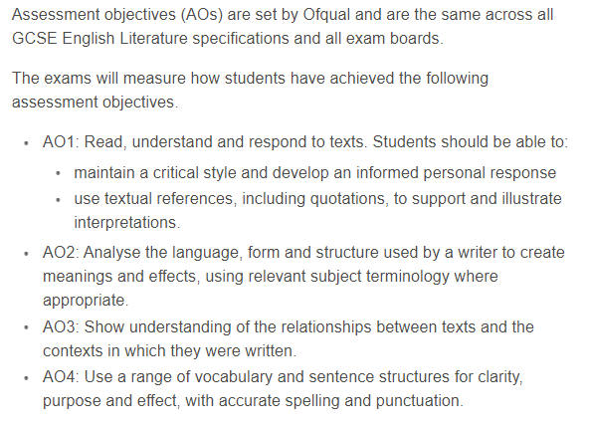
Language and Literature Assessment Objectives



