EARLY HELP KEYHAM LODGE SCHOOL
Supporting families

Early Help
What do we mean by Early Help?
Early Help means taking action to support a child, young person or their family early in the life of a problem, as soon as it emerges. It can be required at any stage in a child’s life from pre-birth to adulthood, and applies to any problem or need that the family cannot deal with or meet on their own. It also applies to all children and young people, with any form of need Early Help requires that agencies should work together as soon as a problem emerges or a need is identified to ensure the child gets the right response, and the right services, from the right people at the right time. Our aim is to meet need early and avoid a problem escalating or the need increasing.
Early Help is provided to prevent or reduce the need for specialist interventions unless they are absolutely the correct response to meet the need and resolve the problem. Early Help can be provided in the most complex of circumstances as well as the simplest. Early help means responding promptly if a child is at immediate risk of harm (or has other significant or complex needs) as much as it means responding to a need which only requires advice or guidance.

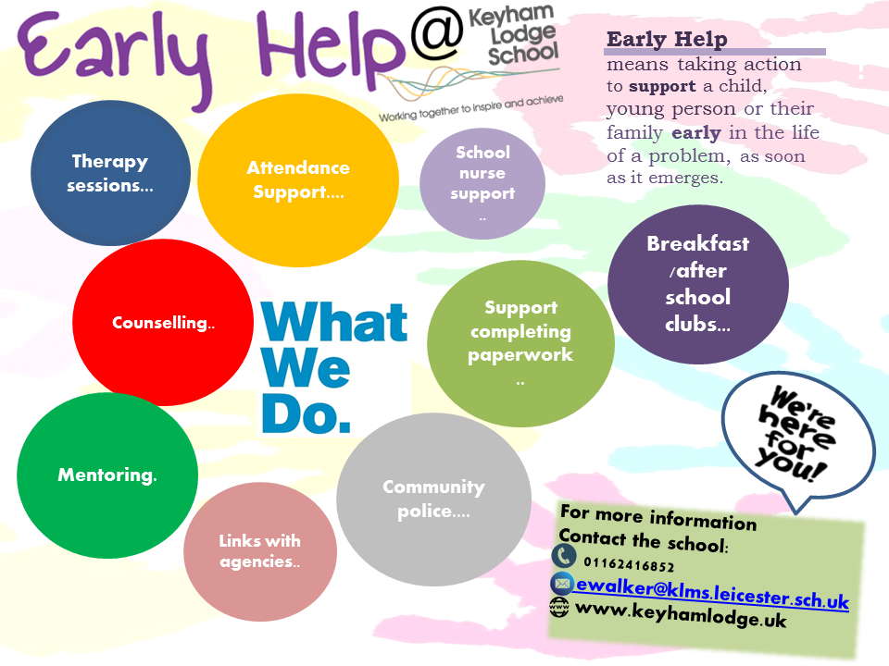
At Keyham Lodge School staff are trained in recognising the signs of Child Abuse and Extremism and are committed to and know the benefit of Early Help as a way of supporting families and young people before their needs become acute and Social Care or other specialist intervention may be necessary.
The school has a range of robust safeguarding procedures in place which puts the safety and protection of children at the heart of any decisions. The school’s safeguarding team is made up of the following school personnel:
- Designated Safeguarding Lead (DSL) – Rebecca Hulcoop/Isaac Marlowe
- Deputy DSL’S – Victoria Edwards, Joe Hill, Kevin Curtis, Nim Sudra, Joe Hill, Richard Doyle, Niall McMahon, Rahi Popat, Nicola Tyers, Jamie Muggleton, Rebecca Cheeseman, Lucy Boyfield.
- E-Safety Manager – Mo Rawat
The DSL and all DDSLs complete inter-agency safeguarding training on a two yearly programme. All other school staff complete safeguarding training on a three yearly basis and are updated regularly to any changes in legislation.

Reporting Concerns
If any member of school suspects that a child may be at risk of harm or who has been harmed they will report the incident through the schools email reporting system. The email is received by all members of the safeguarding team. Staff are expected to report a concern as soon as possible through the reporting system. If a member of staff believes that a child is at risk of or has been subjected to significant harm then this must be reported immediately via email and then in person to either the school’s DSL or one of the DDSLs.
It is school policy that at least two members of the safeguarding team will be on site at any one time and that one of these must be the DSL or a DDSL. This enables all concerns to be reviewed by at least two members of the team at any one time and an appropriate course of action decided upon.
The primary aim of the school’s Early Help systems is to try to intervene early with families before it gets to the stage when a child may be at risk of harm.
Involvement of Families
The school will always involve the family in all Early Help strategies and most will only be put in place with their permission. The school will aim to work with families in a supportive, non-judgemental way so that trust is built up and the best possible outcomes achieved.
There are occasions, however, when the school’s safeguarding team or member of school staff may believe that a child may be at immediate risk of significant harm and that by informing the parents/carers of the concern may put the child at further risk. In these cases the school will implement section 47 procedures. This will involve an immediate referral to social care without the parents/carers knowledge.

School Indicators for Children or Families That May Require Early Help

The following list provides examples of areas where, without intervention a family may break down or a child may be put a risk of neglect, emotional, physical or sexual harm. This also includes the risk of extremism. The school has no pre-prescribed criteria for supporting children and families. Each case is assessed according to needs and a bespoke programme put in place for that child and/or family:
· Low parenting skills;
· Poor diet – obesity, malnourished;
· Low income or poverty;
· Transport;
· Limited community integration;
· Young carer;
· Substance/alcohol abuse;
· Breakdown in family relationships;
· Domestic abuse;
· Breakdown in community relationships;
· Special Educational Needs (refer to local and school offer);
· Child mental health;
· Isolation
· Adult mental health;
· Disability of a child;
· Disability of an adult;
· Bereavement;
· Poor attendance and punctuality;
· Changes in behaviour;
· Poor behaviour and risk of exclusion;
· Child unaware of how to keep themselves safe online;
· Child unaware of danger and how to keep themselves safe;
· Child demonstrates sexualised behaviours;
· Frequent house or school moves.
· Extremist views
· Involved in anti-social or criminal activity;
· Is associated with gangs;
· Frequently goes missing from care of from home;
· At risk of modern slavery, trafficking or exploitation;
· Has returned home to their family from care;
· Is privately fostered.

Following the identification of a family who may require Early Help the school will seek to gain consent from the family to engage with the services who may be best placed to support them. This will most likely involve support from the Local Early Help support team who will work with the school to assess the needs of the family and to complete an 'Action plan' this may also include Team around the Family (TAF) meetings.
The levels of needs for each family is assessed on an individual basis and different levels of services can be accessed as a result. These may include the following:
Universal – All children
- Family
- Friends
- School Staff
- Governors
- Parent Teacher Association (PTA)
- Breakfast Club
- After School Clubs
- Community Clubs (i.e. sports, arts etc.)
Community - Child or family need extra support
- Family Support Worker
- Inclusion Manager
- School Safeguarding Team
- School E-Safety Team
- Police Community Support Officers (PCSOs)
- Police
- GP
Health Visitor
- Midwife
- School Nurse
- Targeted Youth
- Educational Psychologist
- School Staff/IRT Team
- LA SEN Team
- LA Transport Team
- Housing
- Young Carers
- Citizens Advice Bureau
- Job Centre
- CAMHS
- Connexions
- Therapy/Counselling
- Interpreter
- LCI
- Children’s Centre
- Adhd Solutions
- Communication with Previous Settings
Specific - Child or family need specialist support
- Targeted Support Team (TST)
- School Safeguarding Team
- Social Care (Initial/Core Assessment)
- Parenting Courses – Webster Stratton , Triple P, Families and Schools Together (FAST)
- Paediatrician
- Counselling
- ArtSpace – Art Therapy
- 1:1 Therapy from specialist therapists
- Children and Young People’s Services (CYPS)
- Education Entitlement and Inclusion Team (EEI)
- Physiotherapist
- Keep Safe Work
- Occupational Therapist
- Education Psychologist
- Cruse Bereavement Care
- The Samaritans
- Compassionate Friends
- Turning point
- Laura Centre
- ROSA
- Sure start
- Relate
- UAVA
- NSPCC
- Child Online Protection
- Channel Programme
Acute - Child or family need a high level of support to prevent harm
- Social Care – Child Protection (CP), Child in Need (CIN)
- School Safeguarding Team
- Social Worker
- Police – Police Protection Order (PPO)
- Courts – Care Proceedings
- Counselling
- Therapy
- Channel Programme

