

Keyham Classrooms

2024-25

Thinking hard about learning

“The greatest impact on learning is the daily lived experiences of students in classrooms, and that is determined much more by how teachers teach than by what they teach.”
(Dylan Williams)

Curriculum Design: Checklist
Personal Development Curriculum
Intent (clearly linked to school’s Ethos, Vision and Values):
Rationale (written up, making full use of available research in the area):
Clear connection to DfE Character Education Framework Guidance:
Use of Sutton Trust ‘Life Skills’
Addresses Ofsted Framework suggestions:
- intrinsic motivation
- positive moral attributes
- social confidence
- long-term commitments to the wider community
Linked to Keyham Lodge Ambition of Personal Development Offer. Does it build:
- Self-control
- Self-perceptions
- Social skills/Communication
- Resilience- the ability to cope with stress.
- Personal values
Identified set of Skills and/or Knowledge to be taught over:
- a year
- Key Stage
- 5 Years
Assessment Framework that:
- identifies students’ starting point
- measures progress during teaching (way point)
- measures progress after teaching (end point)
Long Term Plan
Medium Term Plan
Short Term Plan (using agreed planning model)

Specialist Curriculum
Intent (clearly linked to school’s Ethos, Vision and Values)
Understanding of ‘What is the distinct purpose of the subject’
A clearly defined end point to work back from
Have you asked the three key questions:
- What does the ‘best of what has been thought and said’ look like in my subject?
- How have I sequenced my curriculum to ensure that pupils will build schemata (mental models) of knowledge?
- What are the key skills and knowledge, what is the appropriate balance between these two in the curriculum and how does this unfold in the way we will teach?

Identified Skill and Knowledge that:

- Ensure the National Curriculum is taught as intended
- The develops Skills and Knowledge of the agreed and desired End point of
  - the year
  - the Key Stage
  - the end of school

An identifiable ‘Narrative’ that defines how learning will progress over the course of learning

Careful consideration of the Cognitive Pattern of Learning that will enable students to build Schema by:
- intervening learning
- revisiting learning
- connecting learning
- recalling learning

A Curriculum Map that makes clear the students’ journey over:
  - the year
  - the Key Stage
  - the end of school

Module Planners that break down learning goals for each module:
- Key Stage 3
- Key Stage 4

Assessment Framework that:
- identifies students’ starting point (pre-assessment)
- measures progress during teaching (way point)
- measures progress after teaching (end point)

- Makes clear the THREE formal assessments over the year (linked to the school’s data drop dates)
Delivery Checklist
Planning:
Collected data and Key Information for each student
Pre-Assessment to identify each students starting point
Clearly defined Learning Intention (personalised as appropriate)
- Select
- Summaries
- Synthesis
Will the students:
- be active
- be collaborative
- take cognitive responsibility
Planned learning sequences that:
- secure planned Learning Intention
- managed the students’ cognitive load
Inclusion of Metacognition and Self-Regulation
Teaching:
A range of methods of participation
whole class work | investigation and problem solving | participation in physical activity
reflecting on what has been learned | research and finding out | work that utilises a range of digital media
independent work | pair work | creative activities
fieldwork and visits to places of educational interest | debates, role plays and oral presentations  TALK | designing and making things

Feedback:
(Planned) Key Questions
Lesson adaptions based on ongoing assessment
Live Marking/Feedback that
- supports Self Efficacy
- identifies where learning has taken place and how this has been achieved
- manageable next steps
- opportunities to act on feedback

Rationale

Intent

The Learning Curriculums at Keyham Lodge School teach our students’ how to become individually successful.

At Keyham Lodge School we believe our educational offer should enable our children to be:
- Successful learners who enjoy learning and who make progress and achieve excellence.
- Confident, resilient individuals who can live safe, healthy, and happy lives.
- Creative, critical thinkers who can approach the world of work with confidence.
- Responsible citizens who can make a positive contribution to society.

This document supports this by creating clarity about what is expected in our classrooms and all other learning environments.
Whilst our students predominantly exist within the DfE definition of ‘Disadvantaged’* (definition Appendix 1) we also consider the gap created between the engaged and the disengaged student, as we know that through engagement children can go on to achieve amazing future successes.

We celebrate and welcome differences within our school community and we want to ensure that all the students in our school are provided with equal opportunities to learn. As such, we will always recognise individual starting points and students’ prior learning to ensure that their learning is personalised to support their individual needs to secure their individual success.

To fully realise this ambition, we have a comprehensive Learning Curriculum. This is made up of a specialist curriculum offer alongside an extensive Personal Development Curriculum.
Our model is rooted in building confidence. We want our students to understand and celebrate self, which will support their ability to learn, in both Personal and Academic studies. This, in turn, will lead to success beyond Keyham.

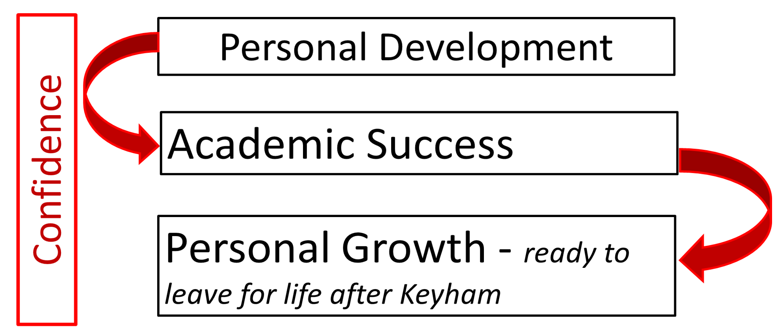

Our Educational Model

Our Curriculum Model:
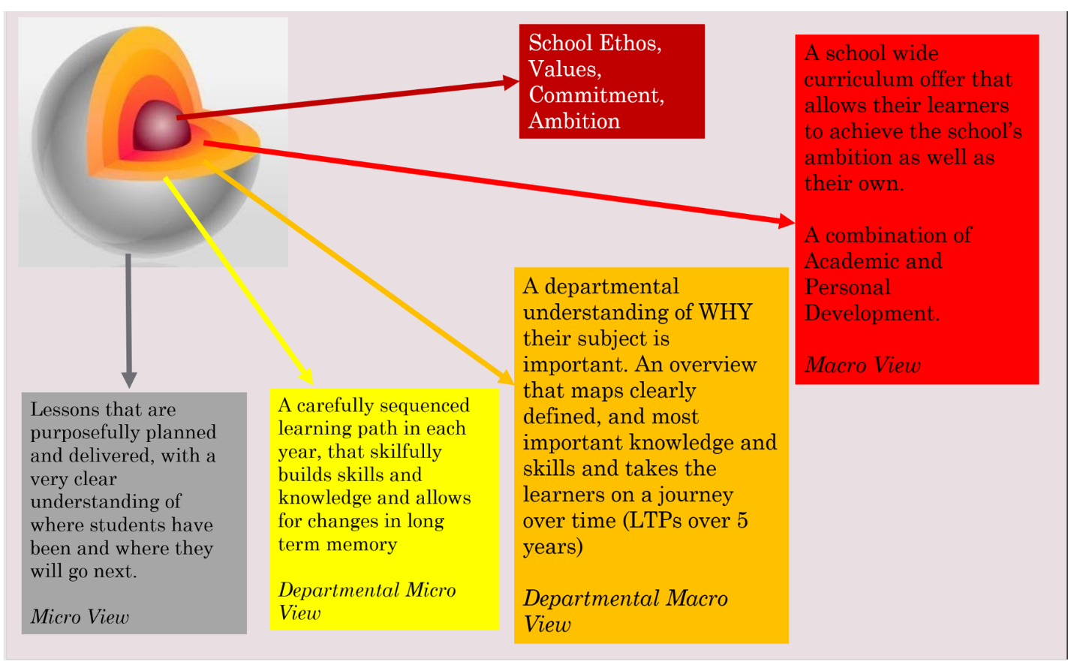

Curriculum Balance

At Keyham Lodge School we aim to provide a broad, balanced and relevant Learning Curriculum.

Our offer comprises a comprehensive specialist curriculum and Personal Development Curriculum that will motivate, engage and challenge pupils whilst also equipping them with the skills required for further study, training or employment.

There are four main schools of thought about the purpose of a school curriculum: to prepare pupils for the workplace, to build character, to further social justice and to teach knowledge for its own intrinsic value
(Turner, 2016)

Personal Development

Keyham Lodge’s Personal Development (PD) offer is at the heart of our school. Our PD curriculum extends beyond the specialist curriculum classroom and provides students broader life experiences to assist in discovering their own interests; it provides rich and diverse learning experiences that are carefully designed to meet the specific needs of our students.
For many of our students developing their understanding of ‘self’ and how to exist in the wider world, is a critical part of their learning journey. Their successes in school are not only measured by their academic outcomes but also by their personal growth.
This is aligned to the DfE’s 2019 ‘Character Education Framework Guidance’ which notes that:
‘Schools have an important role in the fostering of good mental wellbeing among young people so that they can fulfil their potential at school and are well prepared for adult life. Schools with clear expectations on behaviour and with well-planned provision for character and personal development can help promote good mental wellbeing’
Similarly the Sutton Trust 2017 Report, ‘Life Skills’, state:
‘Schools should focus on ensuring a wider range of their pupils develop a broad array of non-academic skills, through both classroom strategies and extra-curricular enrichment activities…
Schools should take a ‘whole-school’ approach to engendering life skills in young people. Life skills education should be embedded in the day to day curriculum, through extra-curricular activities, and through dedicated programmes.’
Our Personal Development Curriculum aims to build students’ confidence so they can become life-long learners and fully realised citizens within their communities and the wider world. We want our students to develop as well-rounded young people who can contribute meaningfully to the wider community and go on to lead happy, successful and healthy lives.
The Ofsted framework in 2019 outlined recommendations for schools about the importance of character development. The guidance framework reduces it down to:
- intrinsic motivation
- positive moral attributes
- social confidence
- long-term commitments to the wider community.
Our PD offer at Keyham Lodge responds to these recommendations through its aims to develop these characteristics in all our learners as:
- Self-control
- Self-perceptions
- Social skills/Communication
- Resilience- the ability to cope with stress.
- Personal values

We anticipate that the balance between Personal Development and Specialist will follow a model similar to the one outlined below. However, we understand that this will not work for all and so within this model, there will be scope to personalise offer even further to meet the specific needs out students.

As a school, we know that this may change year on year to meet the need of the ever-changing cohort; our curriculum design enables us to be both flexible and dynamic in our ability to design an offer that best meets the needs of our students.


Year 11: PD = 25% (this will be much higher for learners who continue to struggle to access learning in the traditional classroom setting - there will be an appropriate split to meet specific need)
SC = 75%

Year 10: PD 35% (this will be much higher for learners who continue to struggle to access learning in the traditional classroom setting - there will be an appropriate split to meet specific need)
SC = 65%

Year 9: PD 45% (this will be higher for learners who continue to struggle to access learning in the traditional classroom setting - there will be an appropriate split to meet specific need)
SC = 55%

Year 8: PD 50% (this will be higher for learners who struggle to access learning in the traditional classroom setting - there will be an appropriate split to meet specific need)
SC = 50%

Year 7: PD 60% (this will be higher for learners who struggle to access learning in the traditional classroom setting - there will be an appropriate split to meet specific need)
SC = 40%

Key stage 3 and Key Stage 4 students will have timetabled lessons that have are specifically focused on Personal Development as well as having a robust Specialist offer.

Our Educational Model is built on the knowledge that true success lies in having the right balance of these two areas without compromising our ambition for deep learning experiences..

CORE

Sitting at the heart of our Personal Development and Specialist offer is our CORE curriculum. The CORE Curriculum offer forms the foundation of what we hope to achieve with the students. Through the CORE offer we aim to develop:
Character
Oracy
Resilience
Emotional Intelligence

All of which we underpin though our 5 key Behaviour Principles:
- Respect
- Honesty
- Trust
- Integrity
- Kindness
Intent: The CORE curriculum at Keyham Lodge School teachers our students to be respectful, responsible and resilient.

The CORE curriculum enables our students to develop the personal skills as well as participate in statutory RSE. Rooted in developing an understanding of the Self and the World, CORE lessons are the foundation of Personal Development at Keyham Lodge.

In addition to CORE lessons, the Personal Development will also include a number of timetabled lesson and non-academic intervention opportunities.

Personal Development Offer

The timetabled Personal Development offer for Year 7 and Year 8 will include:

- CORE
- Practical CORE
- Mentors in Violence Prevention (delivered in Extended Tutor Period)
- Forest School (through which students will also have the opportunity to participate in Science in the Natural World and Creative Writing)
- Wellness
- Real Direction (delivered in Extended Tutor Period)

The timetabled Personal Development offer for Year 9 will include:
- CORE
- Practical CORE
- Mentors in Violence Prevention (delivered in Extended Tutor Period)
- Lifeskills
- Wellness
- Enrichment
- Real Direction (delivered in Extended Tutor Period)

The timetabled Personal Development offer for Key Stage 4 will include:

- CORE (including Careers Education)
- Mentors in Violence Prevention (delivered in Extended Tutor Period)
- MyCORESkills
- Lifeskills
- Wellness
- Real Direction (delivered in Extended Tutor Period)

In addition, all year groups will also participate in:
- Extended Tutor Time Programme
- Assemblies (Topical and Celebration)
- Project Days (linked to PD themes and ideals)
- Student Council
- Extra-Curricular Clubs (after school)

To support this development of the individual and to ensure that our students’ offer meets their specific needs, a range of non-academic interventions that provide students further opportunities to develop ‘self’ will also supplement this. For both Key Stage 3 and Key Stage 4 these will include:
- Key Worker Sessions
- Sessions with BMT on Progressive Masculinity
- Commando Joes
- ESports
- Outdoor Education
- Motor Sports Intervention
- Equine Studies

Specialist Curriculum

As a school, we underpin everything we do with the aspirations that we create for our students. As we support them to grow personally, we also create opportunities for all the students at our school to thrive in exam subjects, regardless of their starting point.

The Specialist offer is designed to ensure that all our students have access to a broad and balanced curriculum, specifically designed around our own school context.

Students at the school also have access to a full complement of subject areas at both Key Stage 3 and Key Stage 4. All students are given the opportunity to learn in:
- English
- Maths
- Science
- Humanities
- ICT
- Art
- DT
- Cooking
- PE

Each Department area has autonomy over the design of their specific curriculum offer.

A school curriculum must be designed with this question in mind, and also respond to the question, ‘What is the distinct purpose of each particular subject?’
(Turner, 2016).

Each are clear on their intent, which determines what is taught. There is a clear understanding of why it is included and what the intended outcome of learning is.

Decisions on both content and development of sequencing are guided by carefully researched principles of successful curriculum design. Three Key Questions are at the centre of these decisions:

- What does the ‘best of what has been thought and said’ look like in my subject?
- How have I sequenced my curriculum to ensure that pupils will build schemata (mental models) of knowledge?
- What are the key skills and knowledge, what is the appropriate balance between these two in the curriculum and how does this unfold in the way we will teach?

If we think of the curriculum as ‘content structured as narrative over time’, which does two jobs: ‘making the next stage possible (a proximal function)’ and also ‘doing an enduring job (an ultimate function) which might come into its own later’ (Counsell, 2018), we begin to get a sense of why we must think about the curriculum as a whole. This requires you to consider the overall structure of your subject.

In ensuring that what is being taught is both relevant and responsive to the needs of our students, all teams have explored the ‘narrative’ of their curriculum. Teachers and leaders will know the journey that students will go on over each year, each key stage and over their five years in our school. All Curriculum maps are designed to ensure with the end point (module/year/key stage/ultimate) in mind.

Curriculum planning in each areas, Specialist Curriculum and Personal Development takes careful note of the journey learning takes in the brain. We understand that planning MUST take int account the fact that for ‘Learning’ to happen, there has to be a change in Long Term Memory.

Department leads are encouraged to use the Narratives of their curriculum to ensure that student have the right opportunities to ensure they are able to build Schema for long-term learning.

Within each subject area, curriculum maps are built to ensure there useful and sufficient opportunities to recall and revisit learning in order to keep schematic learning highly functional for students.
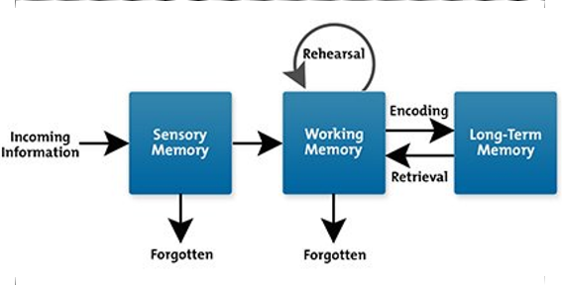

As the cohort of students at Keyham Lodge is every changing, these maps provide a solid foundation whilst remaining adaptable. Department Leads will review their offer year on year and ensure relevant adaptations are made to meet the need of the learners in that specific cohort.

Key Stage 4 Pathways
Transitioning into KS4 sees our students given the opportunity to refine their curriculum by selecting options that feed into their future aspirations.
The school supports students to build an offer that best matches their ability and their future aspirations. This KS4 curriculum offer is built from a range of vocational, BTEC, GCSE, Functional Skills and Entry Level subjects and will include:
- Catering
- Sport
- Mechanics
- Construction
- Beauty
- Art
- DT
- History
- Geography
- Business Studies
- ESports
- Creative Digital Media
- Photography
- Travel and Tourism
- Citizenship
(For all)
- English (Entry Level, Functional Skills, GCSE English Literature, GCSE English Language)
- Maths (Entry Level, Functional Skills, GCSE Maths – Higher and Foundation)
- Science (Entry Level – single and double award, GCSE Biology, GCSE Chemistry, GCSE Trilogy)
We are determined that our students will succeed and be ready for their onward journey. We are therefore fiercely ambitious for all.
This ambition is that all Year 11 students at Keyham Lodge leave with a set a set of qualifications that best reflect their starting point, their ambition and their ability. We want to provide them with every opportunity to progress to their next stage of Education, Training or Employment.

Implementation
Delivery
The Keyham Learning Environment is be based on the simple model below:

Planning

Feedback
Reflection

Teaching

Teachers will work on the cycle of Planning – Teaching – Feedback, all of which will be underpinned by reflection and response to that reflection.
Before the Classroom:
In order to ensure that the teacher and TA are able to provide each student in the classroom with the best opportunities to be successful, they should ensure that they have a secure overview of each student’s starting point, prior learning and their context.
For each student, teachers should have gathered:
Data
- Prior attainment data (from primary, previous school or from previous year)
- Subject specific FFT data
- Literacy Data
- SEN
Context
- Students Passport (including EHCP information and student’s voice)
- An understanding of relationships within the classroom (from tutors, BMT, support staff etc)
- Important information about students’ welfare (from Safeguarding team)
The data and context should provide teachers and TAs with a starting point for each student. However, the information should not be used to lower aspirations of what they can achieve. .
Pre- assessment needs to be a careful consideration at the start of each unit to understand all students’ starting point for learning.

Planning:
As a school, we understand that effective planning is the key to excellent classroom delivery. We know that a carefully planned lesson is the gateway for successful student learning.
As such, we want to ensure that planning is a priority for all teaching.
We have carefully designed a bespoke planner to support teachers with this process.
The expectation is that planning is recorded in The Keyham Planner. As a minimum; Learning Intentions, a brief outline of the learning sequence and planned assessments, should be outlined in Teacher Planners. More detailed planning should also be kept in the planner.
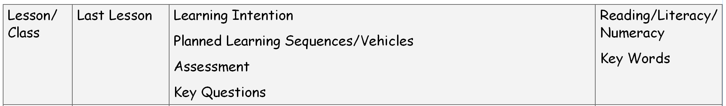

Teachers must be clear and precise about what they want their students to learn:
‘The basic premise is that the students have the same idea as their teacher about what is going on in the classroom, and what they should be learning as a result.. Many students are not going to know this unless it is clearly signposted – learning intentions (or objectives), and learning outcomes (or success criteria) provide this direction.’
(John Hattie)
We expect teachers to THINK HARD about learning in order to demystify it for themselves. In doing so, they will be able to articulate the intended learning and WHY that learning is important to the students.

All teachers need to ensure that what is happening in their classroom is in line with the department’s Long Term Plans and Intended Knowledge Outcomes.

To ensure that there is consistency across the school, teachers will use the model below to:
- Demystify what they are teaching and why
  - Write clearly defined Learning Intentions that articulate learning in a way students can engage with. Ensure the context of that learning (WHY) is shared
- Consider how that learning will be delivered throughout the lesson
  - Think carefully about vehicles for delivery
  - Know the Success Criteria of the lesson. How will the teacher measure the learning? How will Student? What assessment methods will be used?
  - Know how the lesson could be adapted using the on-going assessment
- Support students in articulating their learning in order to embed it and contribute to the developing schema
In lessons, a learning structure is recommended to support Willingham’s simple model of memory implementation. The three components that learning should be broken down into are:
- Select
- Summarise
- Synthesise
For Teachers, this means that in lessons pupils should be able to:

- Select – identify key words
- Summarise – outline what has been said in their own words
- Synthesise – make sense of it - link it to prior knowledge – stick it together – apply it
To explain this in students language, each of the elements can be explained as:
Select – key words may be:
- Key information about your learning topic
- Instruction (telling you what to do)
- Method words that will help you solve a problem
Summarise – Repeat the key information in as few words as possible whilst trying to capture all the important bits
Synthesise – Link your learning! Think hard about what we have learnt, how does it link to what you have learnt before? Stick the new learning together and apply it to this new situation.

Research shows that to learn, we have to:
- Be active
- Be collaborative
- Take cognitive responsibility (doing your own thinking)

This should be an important consideration in the design of all learning sequences and activities.
Put the learners in the driving seat. Allow them to learn by doing, by exploring and by making mistakes.
Learning Sequences and planned activities should be designed in order to secure the intended LEARNING. No activity should be included unless it directly links to the intended learning.

Managing Cognitive Load
“We may need to teach less in order for the students to learn more. Teach less more carefully, and discuss it with our students. We need to clarify the purpose and expected outcomes of the tasks we design for students, and give them specific, clear and constructive feedback, and the chance to use that feedback to improve their own work.” (Sutton 2000)
As a school we pay close attention to ensuring that planned lessons take the students cognitive load into account.
‘The cognitive load involved in a task is the cognitive effort (or amount of information processing) required by a person to perform a task.’
Miller’s Law says that working memory can handle 7 +/- 2 chucks of new information in their working memory. In a classroom that can mean, the new learning being introduced – whether that be a new concept or idea, the methodology to perform a task or the way it will be marked.
In order not to overwhelm the working memory and allow students time to effectively process what is being taught, teachers will plan learning with this in mind. As a school, we will actively avoid ‘coverage’ in lessons and instead place value on deep learning. (*see appendix 2 for strategies to reduce cognitive load)
As part of lessons, teachers should allow students to see what ‘excellent’ looks like.
Excellent should be shared, made visual and be accessible.
For students to strive for it, we understand that they need to know what excellent is and be shown how to get to it. Students should be clear about what is expected of them and their journey to it should be clearly signposted and structured.

Personalisation
It is imperative that learning is personalised to suit the specific needs of the individual in the classroom. This may be through differentiated tasks, approaches or delivery. It is the teacher’s responsibility to ensure they understand how their students learn best and ensure that their specific profile of need is catered for.

Teaching Assistants and Support Staff
It is the responsibility of Teachers to effectively plan for use of other adults in the classroom. Through their incisive knowledge of the students’ needs, teaching staff should ensure that, prior to the lesson (ideally the day before or at least at the start of the day) that all other adults know:
- What the Learning Intention for the lesson is
- How the lesson will be delivered
- The other adults role in the lesson (which student/s will they be working with, key questions, any literacy strategies, their role in any assessment etc)
It is the responsibility of the Teaching Assistant/Support Staff to ensure that this is recorded in their planner (see image below) and anything they are unsure about is clarified before the lesson begins.
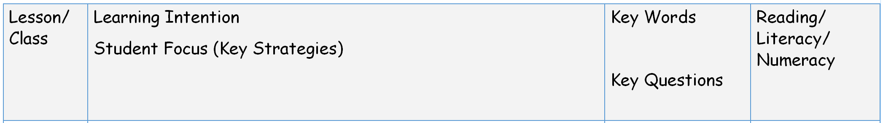
Providing ‘live marking’ will be part of the teaching process. Both teachers and TAs will ensure that students are part of the feedback cycle throughout the lesson. This should help support their understanding and drive learning forward. Instant feedback may also help address misconceptions quickly. Both teachers and TA should ensure that they maintain a dialogue with students throughout the lesson.

All TAs and Support staff will be expected to complete their reflections see image below) after the lesson and use these reflections to:
- Feedback to the teacher about the next lesson’s planning
- Update any relevant behaviour or safeguarding records
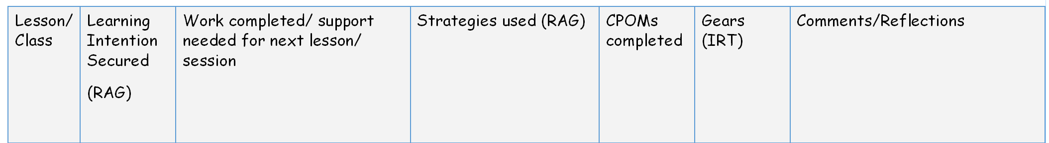
- Pass on any relevant information to other stakeholders

Teaching:
We understand that people learn in many different ways and we recognise the need to develop strategies that allow all children to learn in ways that best suit them. So, at Keyham Lodge, students will have the opportunity to participate in:
whole class work | investigation and problem solving | participation in physical activity
reflecting on what has been learned | research and finding out | work that utilises a range of digital media
independent work | pair work | creative activities
fieldwork and visits to places of educational interest | debates, role plays and oral presentations  TALK | designing and making things

The SEND code of practice cites Quality First Teaching will always make the biggest difference to any student in a classroom. So we support our highly skilled practioners to deliver to the best of their ability in all learning environments.
Teachers will always drive the learning in the classroom through the carefully planned lessons. Teachers will develop a climate that is conducive to learning and, more importantly, a space that students enjoy being in.
Teaching in the lesson will always be influenced by each teacher’s unique style and specific relationship with their students.
As teachers we will ensure that we constantly challenge students; challenge them to behave appropriately, challenge them to work to the very best of their ability and challenge them to stretch their thinking. We will always encourage them to be aspirational and strive for excellence.
In order to allow this, teachers will always ensure that student learning is at the centre of every lesson. Teachers will adapt planned teaching during lesson where necessary; where learning takes a difference direction than what is planned, teacher will be brave and allow students to explore (this should be evidenced on reflections – see below).
Learning to Learn (Metacognition and Self-Regulation) *see appendix 3 for full report and poster

A student understanding the mechanisms for their own learning is identified by the Sutton Trust as a low cost, high impact measure to improve attainments (for disadvantaged learners).
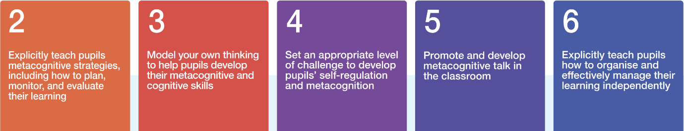
Informed by the EEF’s Metacognition and Self Regulated Learning Report, teachers and other delivery staff are encouraged to think carefully about Recommendations 2-6. As part of the delivery methods in all Learning Environments, teachers should actively try and:

Feedback (Assessment and Marking)
(see Assessment Policy for full breakdown of Assessment Practices at Keyham Lodge School)
Assessment of intended learning should be planned as part of all lessons. This may be done in a variety of forms from questioning through to a more formal assessment at the end of a unit.
Assessment is carried out to check that learning has taken place. It measures the learner’s knowledge and skills in their learning and encourages learners to ask questions about anything they have not fully understood.
Dylan Williams has said:
“The teacher’s job is not to transmit knowledge, nor to facilitate learning. It is to engineer effective learning environments for the students. The key features of effective learning environments are that they create student engagement and allow teachers, learners, and their peers to ensure that the learning is proceeding in the intended direction. The only way we can do this is through assessment. That is why assessment is, indeed, the bridge between teaching and learning.”
(Dylan Wiliam, Embedded Formative Assessment)
Through regular assessment of learning, teachers and TAs should be able to adapt teaching and address students’ misconceptions, which will support their continued learning and progress towards planned Learning Intentions. Where teachers see that intended learning is not happening, they should adapt the lesson in order to re-steer the learning, even if all planned tasks are not completed.
*see Appendix 4 for model that provides Key Strategies of Formative Practice
At Keyham Lodge School, the expectation is that all students complete a ‘Pre-Assessment’ prior to starting any new unit of learning (in all subject areas). As summative assessments are a means to measure, at a particular point in time, we encourage a ‘way point’ assessment during the course of a module/unit to support teachers and students in understanding progress and gaps, using these to inform the rest of the module of study. End Point Assessments are planned as part of all Learning Modules and accessed by students when appropriate.

Marking and Feedback:
Feedback is ‘useful information generated with an agent (teacher, peer, parent or self), related to learning goals, regarding aspects of one’s performance or understanding, which is utilised to improve one’s work.
(EEF toolkit – see appendix 5 for full article)

At Keyham Lodge School, we understand the critical importance of feedback as part of the successful teaching and learning cycle. We recognise that feedback is integral to learning and to responsive teaching, which in turn impacts on student progress; we know that students will learn better if they receive timely and precise feedback.

At its most powerful, feedback can most effectively support student learning. Wiggins says:

‘it is not teaching that causes learning. It is attempts by learner to perform that causes leaning’. With this in mind, it is crucial that through the ‘performance’ process in lessons, teachers and TAs provide feedback that allows student to reflect and improve to reach the specified Success Criteria and Learning Intentions in both the short and long term (Wiggins 1998).

Students at Keyham Lodge will receive written and verbal feedback aimed at the whole class, groups and/or individuals. Staff and departments have the autonomy for choosing their specific types and timing of feedback to maximise impact and ensure students are making sustained progress in lessons and over time*. We do stipulate however, that all feedback, whether it be teacher, TA, self or peer feedback, should be specifically linked to the specified Learning Intention and/or Success Criteria.

*All Department have an individualised Feedback Policy, that is supported by the latest EEF Guidance Report of Effective Feedback and Marking (appendix 5)

When providing feedback (written or verbal), the comments should ALWAYS be about the learning NOT the task. Feedback should enable students to generate ideas on improvement and development. They should be doing the THINKING. You should be guiding that thinking.

As a school, we want feedback to have a dual purpose:
- Improving Learning
- Promote Self Efficacy
‘Teachers would be well served by paying as much attention to students’ perceptions of competence as to actual competence, for it is the perceptions that may more accurately predict students’ motivation and future academic choices.’

The principles of marking should be rooted in the following:
- Make feedback frequent, detailed and positive (in form most appropriate – verbal, written, whole class, group or personal )
- Offer feedback emphasising goal progress and highlighting personal capacities in order to increase students’ self-efficacy AND identify learning goals
- Feedback should refer to what students are learning rather than simply evaluating their answers as correct or incorrect.
- When students give an incorrect response, examine their thinking processes to ascertain why they misunderstood. Use this opportunity to re-teach or clarify, so as to further support the student’s efficacy.
- Focus on effort and strategies in attributing the reason for success: for example, ‘the effort you showed by restudying the words you missed paid off – look at the improvement you’ve made’.
- know and identify common misconceptions and close gaps in understanding by adjusting teaching to respond to what has not been mastered.
- Teach students to expect to make mistakes, and treat mistakes as opportunities to learn and gain useful feedback from others. This can retrain students’ interpretations of setbacks and build resiliency.
- Have a clear overview of a students’ progress during a lesson, over a series of lessons and in assessments, and plan lessons accordingly.
(some ideas taken from Strategies for promoting self-efficacy in students 2019)
- When marking for Literacy, all staff should use the whole-school marking code) *see appendix 7)
- Maintain high expectation of all students’ work.
- Evaluate the quality of students work,

Feedback can occur at three common stages in the learning process:
- Immediate feedback (live) – at the point of teaching
- Summary feedback – at the end of a lesson/task /topic /assessment
- Review feedback – away from the point of teaching (including personalised written comments) * (see appendix 6 for details of what each looks like)
Feedback closest to the point of teaching is likely to be most effective in driving further improvement and learning, therefore ‘live feedback’ should become the priority feedback in day-to-day teaching. There is an expectation that students should receive feedback, to which they can respond, in all lessons – this may come from teacher, TA, peers or self.
All feedback provided to students should be specifically linked to the quality of students effort towards their learning, their learning and how to improve it. Feedback for students should in the main be C1, C2, D1 and D2
 | Judgemental |  | Related to Task
 | A1 – Rewarding | B1- Approving | C1- Specifying Attainment | D1- Constructing Achievement
Positive Feedback | Unidirectional  Teachers dispense with rewards to students like stickers, stamps, certificates etc. | Unidirectional  Teacher expresses feeling of personal pride in the students and/or their work. | Unidirectional  Teacher identifies standards and specific praise about level of competence of the work. | Two Way Discussion  Teacher with student explores and reflects on the quality and standards or work and learning | Achievement Feedback
 | A2 - Punishing | B2 - Disapproving | C2 - Specifying Improvement | D2- Constructing the way forward
Negative Feedback | Unidirectional  Teacher dispense punishment to students | Unidirectional  Teacher expresses feeling of disappointment and/or annoyance at students perceived fault | Unidirectional  Teacher point out errors/mistakes related to the task. Improvement targets are set including practicing getting something right. | Two Way Discussion  Teacher gives more responsibility to the student by providing suggestions or asking questions so that the students make choices for themselves. | Improvement Feedback

*see appendix 8 for a guide on an excellent model of how to structure feedback to optimise student learning
Teachers should only talk about grades in formal assessment pieces.

Errors
‘Feedback is most effective when students do not have proficiency or mastery – and thus thrives when there is error or incomplete knowing and understanding. Errors invite opportunity…[Errors] should not be seen as embarrassments, signs of failure or something to avoided. They are exciting, because they indicate a tension between what we know and what we would know: they are signs of opportunity to learn and they are to be embraced.’
(Hattie 1996)

Errors are part of learning and should be used by teachers and students to further their learning. Teachers and students at Keyham Lodge School will embrace errors – they will ALWAYS be seen as an opportunity to think deeply.

As part of their daily practice, teachers will also ensure they follow the school’s behaviour policy, issuing rewards and sanctions appropriately.

Reflection and Response:
After all lessons teachers should reflect on each lesson in the Keyham Planner. The key questions that should be addressed are below.

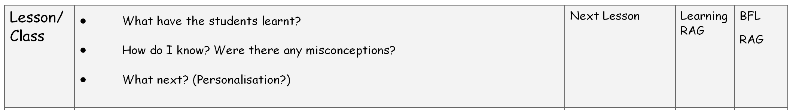

In order to fully understand how successfully the students have learnt, teachers will need to ensure that they have used the lesson itself, the feedback provided during the lesson and the work that students have produced to understand how successful the planning was – they should be asking themselves (through the questions above) *did the students learn today*.
The reflections from the lesson should inform the planning for the next lesson.
It is critical that teachers use these reflections to inform their planning for the next lesson – the successes should be used to plan future learning, misconceptions from the lesson should be addressed and re-taught, if necessary, the level of personalisation re-addressed if necessary and any key students identified. The planning for the next lesson should follow the same expectations as identified in the ‘Planning’ section above.
The cycle of Planning-Teaching-Feedback should continue in this manner throughout the year, helping to ensure that the quality of education that the student receive every day is based on high quality learning that has them and their needs at the very centre.

Monitoring
During all QA, Work Scrutinies and Lesson Visits, teacher will be asked to provide their planner, which should have all planning and reflections, alongside with a selection of books. Observers/SLT should be able to triangulate the work in students’ books with planning and reflections in teachers’ planners.

Department Optimising Learning:
Each department will continue to have their own Optimising Learning documents, which will outline the expectations within each department area.

Appendices

Appendix 1
- Includes any child aged 5-16 who is claiming free school meals.
- Includes any child who has been recorded as claiming free school meals at any point in the past six years.
- Includes any child in this age bracket looked after by a local authority.
- Includes any child in the age bracket recorded by their school as having left care through adoption or another court order
Appendix 2
Reducing Cognitive Load for Learners
- Reducing the overall amount to be covered (and therefore stored)
- Contextualise learning – make it relevant and real for your learners
- Connecting new knowledge to what learners already know
- Introducing new material in small, connected steps – use a simple to complex sequence (assume that the learner is a novice not an expert)
- Reducing processing demands by re-structuring multi-step tasks into separate independent steps Show them what they are working towards (what excellent looks like)
- Create opportunities for deep thinking
- Create time to review before and after learning
- Revisit content
- Low stakes testing
- Keep things focused – try and avoid distractions either emotional or environmental (if they occur, assume that learning has not really taken place)
- Solid classroom routines

Appendix 3

Full Report
EEF_Metacognition_and_self-regulated_learning.pdf (d2tic4wvo1iusb.cloudfront.net)

Poster
Summary_of_recommendations_poster_2021-10-27-151056_qiiz_2021-10-29-074723_miux.pdf (d2tic4wvo1iusb.cloudfront.net)

Appendix 4
The model below provides Key Strategies of Formative Practice. They should provide the cornerstone for effective Planning, Teaching and Learning in all classrooms at Keyham Lodge School. (see link for article to support)
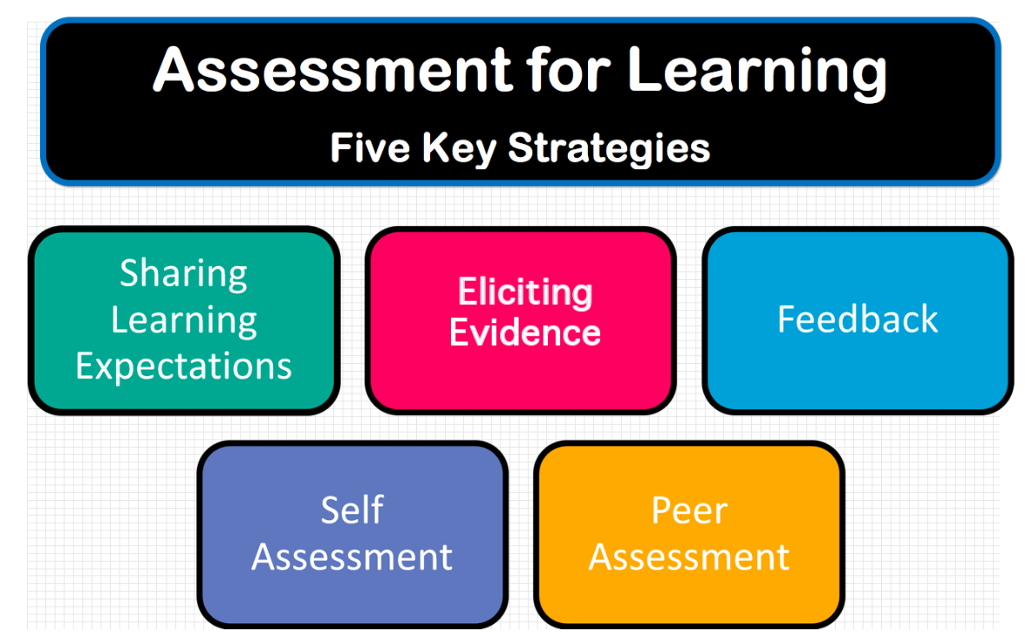

https://teacherhead.com/2019/01/10/revisiting-dylan-wiliams-five-brilliant-formative-assessment-strategies/

Appendix 5
https://educationendowmentfoundation.org.uk/evidence-summaries/teaching-learning-toolkit/feedback/#closeSignup
https://educationendowmentfoundation.org.uk/news/eef-publishes-new-guidance-report-teacher-feedback-to-improve-pupil-learning

Appendix 6
Type | What it looks like in practice:
Immediate  Feedback | - Live verbal feedback, linked to the learning intention, being given to students for immediate action. This can take various forms in lessons with individuals, small groups or the whole class  - Feedback being given regarding the quality of content, attitude to learning and / or presentation  - Re-directing the focus of teaching or the task, based on teacher evaluation of learning in the lesson  - ‘Live’ highlighting/annotations by the students or the teacher  - Students engaging with the feedback given and responding, in discussion or in writing, making improvement annotations/ live corrections  - Students are able to articulate where they are in their learning, what they have learned and what they need to do to improve
Summary  Feedback | - Mini plenaries/ Evaluation of Learning at the end of tasks or phases of learning and plenaries at the end of lessons  - Giving feedback to the whole class or groups and inviting a response from students who should check and amend their work/thinking.  - Teacher evaluating learning in the lesson compared to the Learning Intention  - Students completing self- or peer- assessment tasks against success criteria  - Sharing model answers or ‘work in progress’ from pupils in the group  - Students knowing how to peer and self-assess effectively and have developed habits of engaging personally with summary feedback  - Students being able to self-evaluate realistically, against learning intention.  - Students being able to articulate where they are in their learning, what they have learned and what they need to do to improve
Review  Feedback | - Marking (informal and formally) assessed pieces.  - Spending time evaluating students learning away from the point of teaching  - Personalising written comments/annotations in exercise books/on assessments from the teacher and action using  - Taking the opportunity to thoroughly diagnose skill/understanding gaps away from the lesson and so evaluate pupil progress over time and then inform future planning  - Adaptations to teaching lesson sequences and tasks when compared to original planning  - Dialogues with students/whole class regarding where they are in their learning and key areas to focus on to improve  - Specific targets being set for pupils to support further progress

Appendix 7
Code | Explanation
Sp  (with word underlined) | Try this spelling again
o | Missing full stop or comma
// | Begin a new paragraph
exp | Awkward expression
T | Mistake in the use of tense
WO | Show your working out
Cap (with letter circled) | Capital letter should have been used
ss | Sentence structure is unclear
v | Vocabulary choice is inappropriate or could be improved
? | Meaning is unclear
✓ ✓ | Indicates excellent section of work or a particularly well chosen word or phrase
^ | word missing/insert word or letter

Appendix 8
Developed by: N. Sudra (June 2024) Reviewed: June 2024

The diagram below provides guidelines on the excellent model of how to structure feedback to optimise student learning. Teachers at Keyham will consider the steps, the questions and the conditions when planning the feedback cycle with their students.
Three Key Questions for Learners
FEED UP
FEED UP
FEED UP
3.

2.

1.

What should I do to ‘improve’? How can I close the gap between where I am and where I intend to be?
Feedback Steps
Feedback Questions
Feedback Conditions (Ramprashad 1983)
How am I doing so far, related to the learning intention? How am I going?
What am I going to learn? What are the learning intentions? What is expected? What does ‘good’ look like?
Key questions that drive dialogue and learning in the classroom.
Comparison between the reference and actual level. Identifies new information that influences what happens next
By finding out how well you are doing, you are establishing your current or actual level of performance
Learning intentions are the means of establishing the goal or reference level for learning to be undertaken.
By finding out how well you are doing, you are establishing your current or actual level of performance
Learning intentions are the means of establishing the goal or reference level for learning to be undertaken.

