Science Curriculum

Projects for Key Stage 3

Contents

- Introduction
- Intent of the curriculum
- Learning Journey
- Prior learning
- Future destinations
- Projects
- Introduction to Science
- Cluedo
- Space Invaders
- Pandemic!
- Football Manager
- SIM City
- Asteroids
- Rollercoaster Tycoon
- Mario Kart
- Robot Wars
- Assessment
- Overview of assessment structure
- Retrieval practise (Blue arrow work)
- Individual assessments for projects
- Grading and Understanding Bands
- Appendices
- Excellent work examples by project
- Inter departmental links
- Key stage 4 assessment objective links by project
- Work experience and Life experience opportunities by project

- Introduction

Intent of the curriculum:
The science curriculum has been developed with the intention of ensuring all students develop a deep understanding of the scientific world in which they live.
All students studying the curriculum will be taught what they need to understand and improve an increasingly scientific world.
Learning Journey:
Prior Learning:
During years 5 and 6, pupils should be taught to use the following practical scientific methods, processes and skills through the teaching of the programme of study content:
- Planning different types of scientific enquiries to answer questions, including and recognising and controlling variables where necessary.
- Taking measurements, using a range of scientific equipment, with increasing accuracy and precision, taking repeat readings when appropriate.
- Recording data and results of increasing complexity using scientific diagrams and labels, classification keys, tables, scatter graphs, bar and line graphs.
- Using test results to make predictions to set up further comparative fair tests.
- Reporting and presenting findings from enquiries, including conclusions, causal relationships (and explanations of) and degree of trust in results, in oral and written forms such as displays and other presentations.
- Identifying scientific evidence that has been used to support or refute ideas or arguments.
For living things and their habitats, pupils should be taught to:
- Describe how living things are classified into broad groups according to common observable characteristics based on similarities and differences, including micro-organisms, plants and animals.
- Give reasons for classifying plants and animals based on specific characteristics.
For animals including humans, pupils should be taught to:
- Identify and name the main parts of the human circulatory system, and describe the functions of the heart, blood vessels and blood.
- Recognise the impact of diet, exercise, drugs and lifestyle on the way their bodies function.
- Describe the ways in which nutrients and water are transported within animals, including humans.
For evolution and inheritance, pupils should be taught to:
- Recognise that living things have changed over time and that fossils provide information about living things that inhabited the Earth millions of years ago.
- Recognise that living things produce offspring of the same kind, but normally offspring vary and are not identical to their parents.
- Identify how animals and plants are adapted to suit their environment in different ways and that adaptation may lead to evolution.
For light, students should be taught to:
- Recognise that light appears to travel in straight lines.
- Use the idea that light travels in straight lines to explain that objects are seen because they give out or reflect light into the eye.
- Explain that we see things because light travels from light sources to our eyes or from light sources to objects and then to our eyes.
- Use the idea that light travels in straight lines to explain why shadows have the same shape as the objects that cast them.
For electricity, students should be taught to:
- Associate the brightness of a lamp or the volume of a buzzer with the number and voltage of the cells used in the circuit.
- Compare and give reasons for variations in how components function, including the brightness of bulbs, the loudness of buzzers and the on/off position of switches.
- Use recognised symbols when representing a simple circuit in a diagram.

Future Destinations:
The curriculum provides students with experience of the different courses offered within Science at key stage 4 (Combined Science GCSE, Single Sciences GCSE, Sports Science Cambridge National, Horse Care and Management, Health and Social Care Cambridge National, Entry Level Certificate).

Key stage 4 course | Project Link
Trilogy (combined science double GCSE) | All projects
Biology (single science GCSE) | Cluedo  Space invaders  Football manager  Rollercoaster tycoon  Pandemic
Entry Level Certificate | All projects

- Projects

Introduction to Science:
Project Title: Introduction to Science
Project Intentions
- Understand what Science is and how to be safe while studying
Knowledge | Scientific Skills
- Understand that different types of scientist study different areas of science  - Know what the different areas of science are  - Know that scientific process includes; devising a theory, researching the theory, designing a practical to test the theory and then analyzing the results in relation to the theory | - Identify scientific apparatus used in the lab and its uses  - Devise a theory/hypothesis  - Design a practical to investigate a hypothesis  - Analyse practical results to confirm or dismiss a hypothesis
Concrete links to the real world:
- Scientific process is used in many everyday situations, such as development of new medicines, finding faults in electrical circuits and even bug fixing in computer games/website design

Suggested Learning Journey
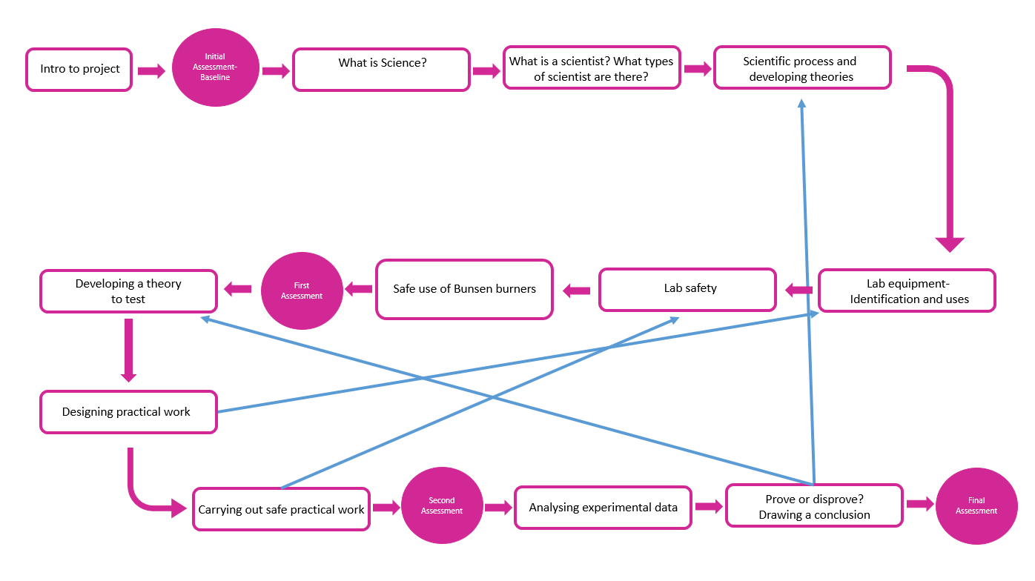

Cluedo:
Project Title: Cluedo
Project Intention
- Have an understanding of crime scene analysis and forensic examination of evidence
Knowledge | Scientific Skills
- Cells are the fundamental units of living organisms, including how to observe, interpret and record cell structure using a light microscope.  - The functions of cell organelles, including cell membrane, cytoplasm, nucleus and mitochondria.  - Heredity as the process by which genetic information is transmitted from one generation to the next.  - A simple model of chromosomes, genes and DNA in heredity, including the part played by Watson, Crick, Wilkins and Franklin in the development of the DNA model.  - The concept of a pure substance and what a mixture is.  - Simple techniques for separating mixtures: filtration, evaporation, distillation and chromatography.  - The similarities and differences between light waves and waves in matter.  - Ultraviolet and Infrared as part of the electromagnetic spectrum and their uses for crime prevention/detection.  - Blood splatter analysis as part of crime scene investigation.  - The individuality of fingerprints, different methods of collecting fingerprints from people and from surfaces, analysis of fingerprint types and comparisons. | - Applying variables  - Applying relationships between science and society to specific situations  - Drawing graphs and analysing graphical data  - Writing methods  - Analysis of secondary data  - Assessing impacts of scientific concepts  - Modelling scientific concepts  - Synthesising several theories to draw conclusions  - Applying maths to the scientific concepts  - Applying knowledge of risk to create risk assessments  - Identify and analyse patterns in data and behaviour
Concrete links to the real world:
- Inheritance of genetic traits through their family tree.
- Methods of crime prevention as well as crime investigation.
Suggested Learning Journey
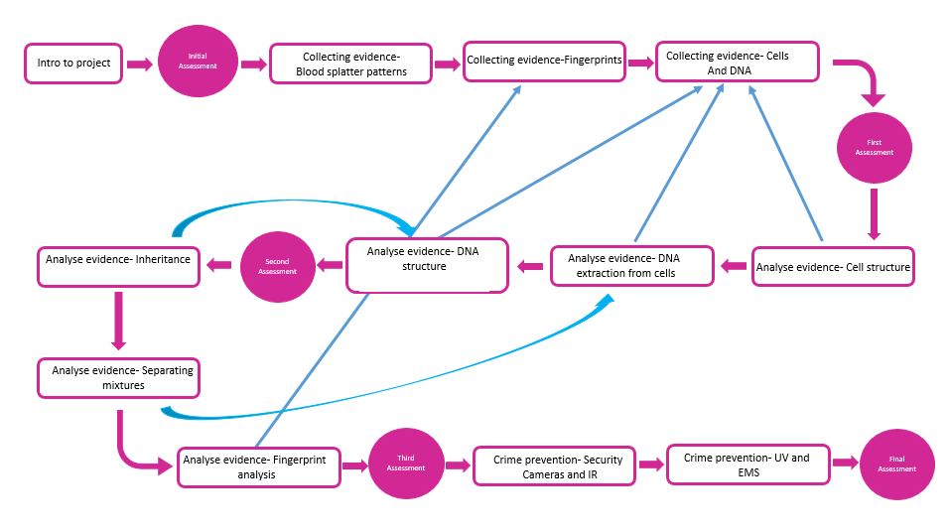

Space Invaders:
Project Title: Space Invaders
Project Intentions:
To understand the real life implications of space travel and space exploration
Knowledge | Scientific Skills
- The importance of plant reproduction through insect pollination in human food security  - How organisms affect, and are affected by, their environment, including the accumulation of toxic materials  - Heredity as the process by which genetic information is transmitted from one generation to the next  - A simple model of chromosomes, genes and DNA in heredity, including the part played by Watson, Crick, Wilkins and Franklin in the development of the DNA model  - Differences between species  - The variation between species and between individuals in the same species can drive natural selection  - Changes in the environment may leave individuals within a species, and some entire species, less well adapted to compete successfully and reproduce, which in turn may lead to extinction  - The importance of maintaining biodiversity and the use of gene banks to preserve hereditary material  - The similarities and differences between light waves and waves in matter  - Light waves travelling through a vacuum and the speed of light  - The transmission of light through materials: absorption, diffuse scattering and specular reflection at a surface  - Light transferring energy from source to absorber leading to chemical and electrical effects; photo-sensitive material in the retina and in cameras  - Our Sun as a star, other stars in our galaxy, other galaxies  - The seasons and the Earth’s tilt, day length at different times of year, in different hemispheres  - The light year as a unit of astronomical distance  - Non-contact forces: gravity forces acting at a distance on Earth and in space, forces between magnets and forces due to static electricity | - Use of ray model to explain imaging in mirrors, pinhole cameras, the refraction of light and the action of convex lens in focusing (qualitative); the human eye and telescopes  - Calculate gravity and weight on different planets  - Calculate travel time to distant planets in AU
Concrete links to the real world:
With advances in science and technology there is growing interest in space and space travel.
Suggested Learning Journey
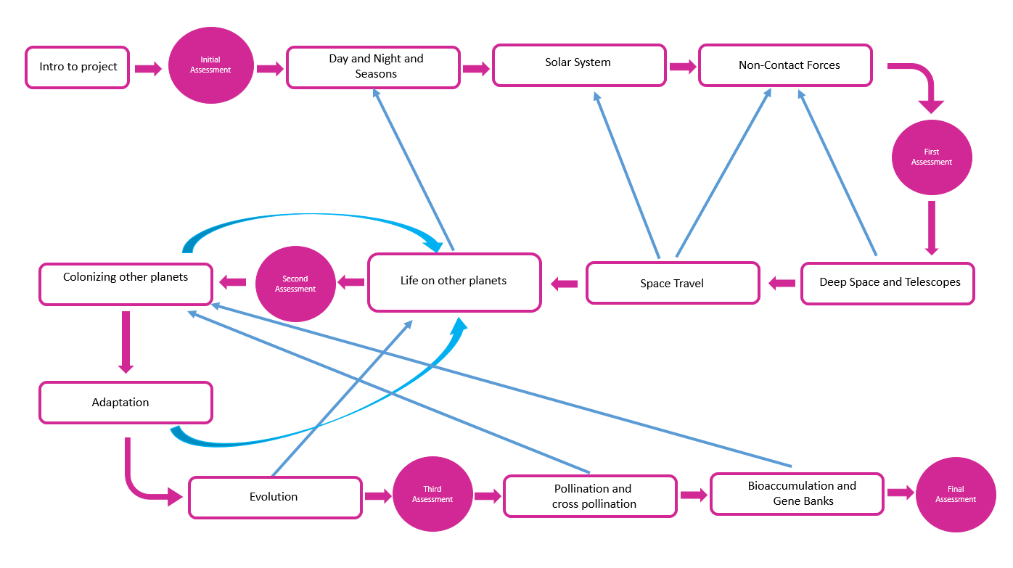

Pandemic!
Project Title: Pandemic!
Project Intentions:
To understand the implications of a pandemic on our lives.
To understand ways in which we can protect ourselves from diseases.
Knowledge | Scientific Skills
- Cells as the fundamental unit of living organisms  - The role of diffusion in the movement of materials in and out of cells  - The structural adaptations of some unicellular organisms  - Content of a healthy diet: carbohydrates, lipids, proteins, vitamins, minerals, fibre and water  - The tissues and organs of the human digestive system, including adaptations to function and how the digestive system digests food  - The consequences of imbalances in the diet on the immune system  - The importance of bacteria in the human digestive system  - The effects of recreational drugs (including substance misuse) on behavior, health and life processes | - How to observe, interpret and record cell structure using a light microscope  - Calculations of energy requirements in a healthy daily diet
Concrete links to the real world:
Having just experienced a real life pandemic this project will allow students the chance to get to grips with what has happened and why.

Suggested Learning Journey
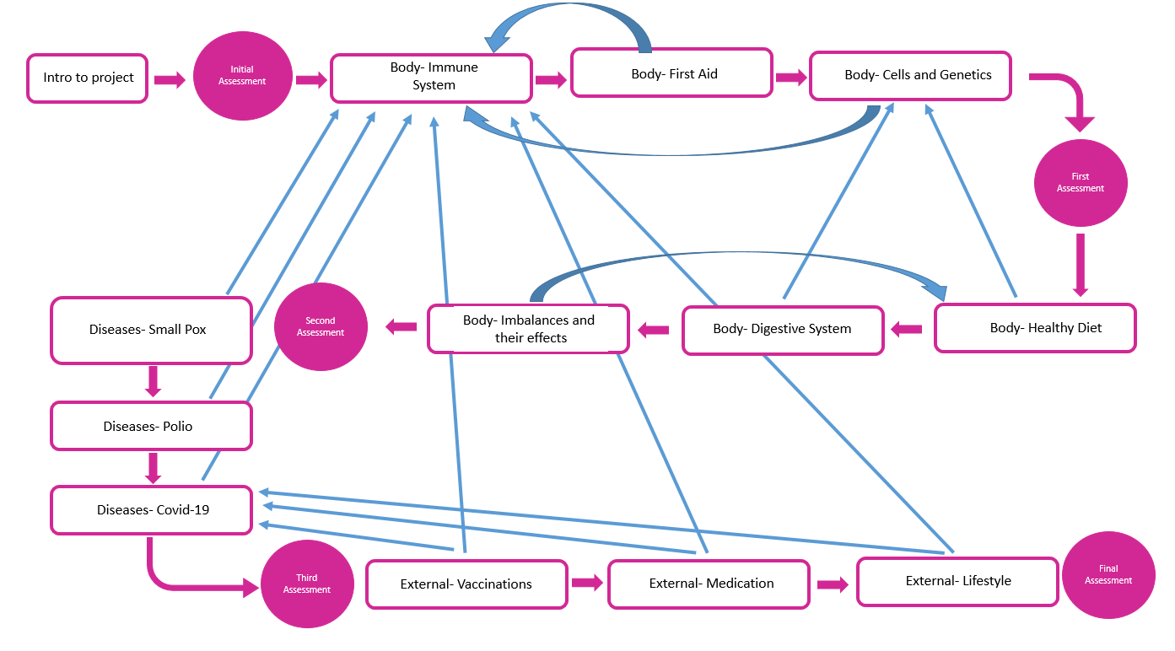

Football Manager:
Project Title: Football Manager
Project Intentions
- Understand what is involved in managing and training a football team
Knowledge | Scientific Skills
- Functions of the human skeleton  - Muscles and bones interact to create movement  - Energy for movement comes from respiration  - Common sporting injuries, how they can be prevented and how they can be treated  - Reactants for respiration come from organ systems  - Structure and function of the cardiovascular system  - How the body obtains glucose  - Structure and function of the nervous system  - How drugs and alcohol affect sporting performance- including effects of specific legal and illegal drugs  - How diet affects sporting performance  - How sporting performance can be monitored (speed etc.)  - How communication is used in sport (managers to players etc)  - How humans communicate with each other  - Understanding variables  - Understanding relationships between science and society | - Applying variables  - Applying relationships between science and society to specific situations  - Drawing graphs and analysing graphical data  - Writing methods  - Analysis of secondary data  - Assessing impacts of scientific concepts  - Modelling scientific concepts  - Synthesising several theories to draw conclusions  - Applying maths to the scientific concepts  - Applying knowledge of risk to create risk assessments  - Identify and analyse patterns in data and behaviour
Concrete links to the real world:
Many students are interested in sports and entering the world of sports as a career in the future
Understanding how their bodies work and how it can be affected by injuries, drugs and diet etc.
Knowing how communications devices work

Suggested Learning Journey
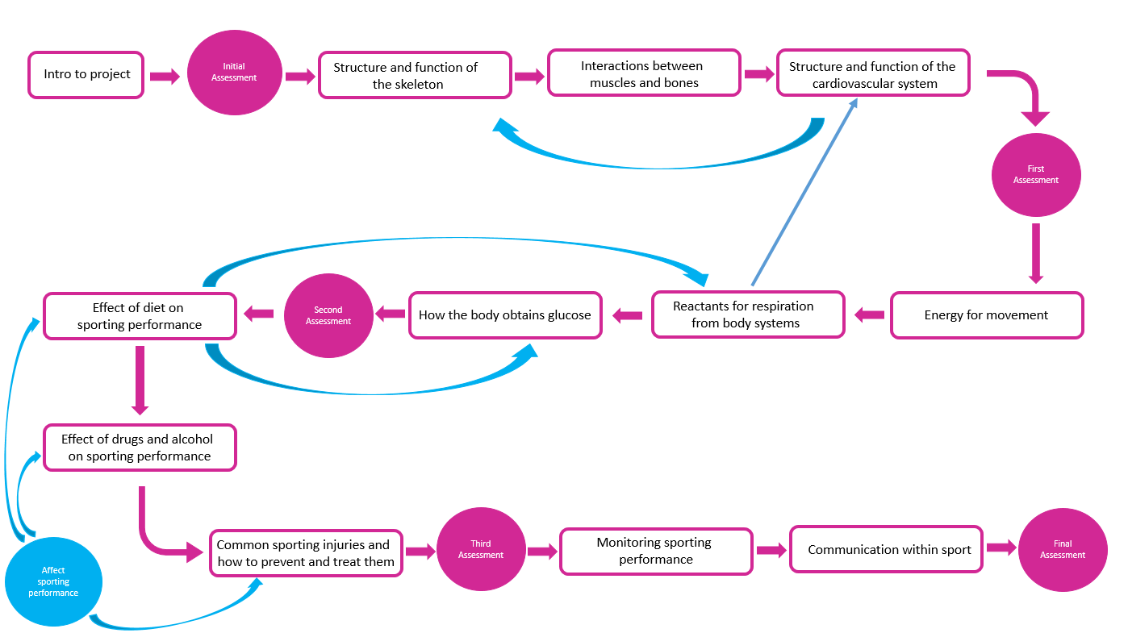

Sim City:
Project Title: Sim City
Project Intentions
- Understand that cities require resources and materials from the natural environment to provide the lifestyle we are used to
Knowledge | Scientific Skills
Non-contact forces magnetism etc- mag lev trains!!!  -magnets have poles, opposites attract and like poles repel.  -Earth is a magnet, compasses align to the Earth’s poles allowing for navigation.  -The magnetic effect of a current, electromagnets, d.c. motors.  - Energy is obtained from renewable and non-renewable resources  -Photosynthesis  -The reactants in, and products of, photosynthesis, and a word summary for photosynthesis.  -The dependence of almost all life on Earth on the ability of photosynthetic organisms, such as plants and algae, to use sunlight in photosynthesis to build organic molecules that are an essential energy store and to maintain levels of oxygen and carbon dioxide in the atmosphere.  - How electricity is produced.  Earth and atmosphere  -The structure and composition of the Earth.  - The rock cycle and the formation of igneous, sedimentary and metamorphic rocks.  -Earth is a source of limited resources and the efficacy of recycling.  -The carbon cycle  -The composition of the atmosphere  -The production of carbon dioxide by humans activity and the impact on climate.  Chemical reactions  -The processes of combustion, thermal decomposition, oxidation and displacement reactions.  -What catalysts do.  Materials  -The order of metals and carbon in the reactivity series.  - the use of carbon in obtaining metals from the metal oxides.  - properties of ceramics, polymers and composites (qualitative) | - Applying variables  - Applying relationships between science and society to specific situations  - Drawing graphs and analysing graphical data  - Writing methods  - Analysis of secondary data  - Assessing impacts of scientific concepts  - Modelling scientific concepts  - Synthesising several theories to draw conclusions  - Applying maths to the scientific concepts  - Applying knowledge of risk to create risk assessments  - Identify and analyse patterns in data and behaviour
Concrete links to the real world:
Understanding how their homes are built and powered. Closing the gap between nature and society.
Suggested Learning Journey
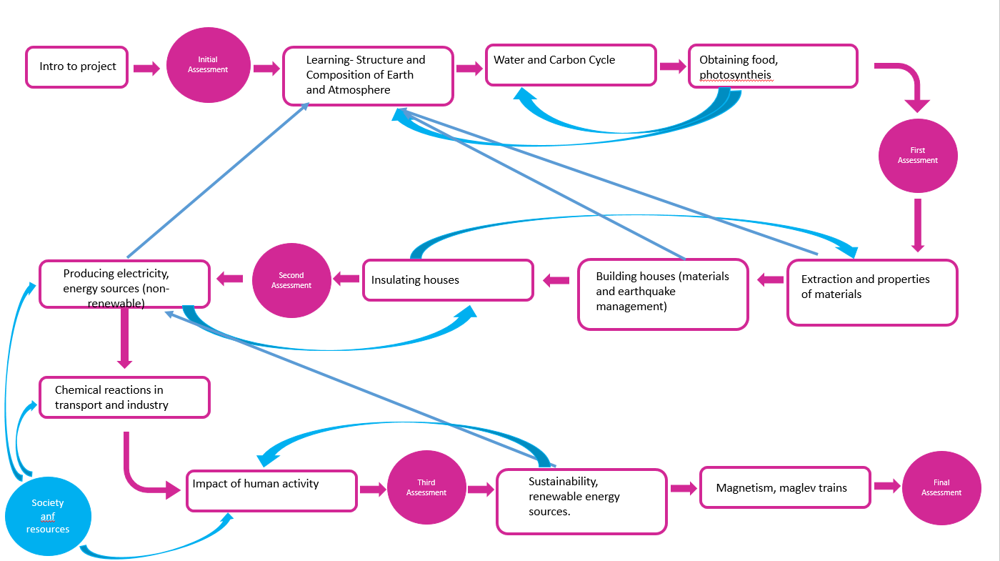

Asteroids:
Project Title: Asteroids
Project Intentions
- To understand the structure and composition of matter
- To know where matter originates and how we know.
Knowledge | Scientific Skills
To know the varying physical and chemical properties of different elements  To know the principles underpinning the Mendeleev Periodic Table  To understand the Periodic Table: periods and groups; metals and non-metals  To know how patterns in reactions can be predicted with reference to the Periodic Table  To know the properties of metals and non-metals  To know the chemical properties of metal and non-metal oxides with respect to acidity.  To know a simple (Dalton) atomic model of the atom  To know the differences between atoms, elements and compounds  To know chemical symbols and formulae for elements and compounds  To understand conservation of mass, changes of state and chemical reactions.  To describe chemical reactions as the rearrangement of atoms.  To know how to represent chemical reactions using formulae and equations  To know the properties of the different states of matter (solid, liquid and gas) in terms of the particle model, including gas pressure  To explain changes of state in terms of the particle model.  Describe changes with temperature in motion and spacing of particles  To understand there is internal energy stored in materials.  To know a near-Earth object (NEO) is any small Solar System body whose orbit brings it to proximity with Earth, this includes asteroids.  To know the structure and composition of asteroids  To know all elements originate in stars.  To know stars use fusion to create elements up to iron. Then when the star explodes further elements are created.  To know celestial objects can be tracked using Redshift and EM spectrum  To know part of the EM spectrum is harmful to life  To know the atmosphere protects us from UV and asteroids (due to high air pressure)  To know The theory of the Big Bang as the origin of the universe  To know How humans can live in space (ISS) | - Applying variables  - Applying relationships between science and society to specific situations  - Drawing graphs and analysing graphical data  - Writing methods  - Analysis of secondary data  - Assessing impacts of scientific concepts  - Modelling scientific concepts  - Synthesising several theories to draw conclusions  - Applying maths to the scientific concepts  - Applying knowledge of risk to create risk assessments  - Identify and analyse patterns in data and behaviour
Concrete links to the real world:
Broadens students’ concept of reality as they begin to appreciate the world in which we live is a tiny part of a hierarchy of organisation spanning from atoms to the universe.
Suggested Learning Journey
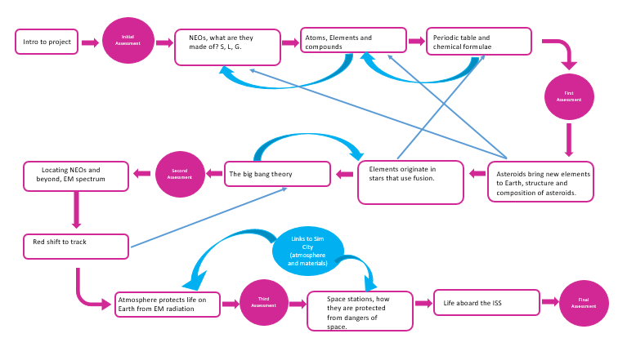

Rollercoaster Tycoon:
Project Title: Rollercoaster Tycoon
Project Intentions:
To understand the science in designing rollercoasters
To understand the factors involved in opening and maintaining an animal-based attraction
Knowledge | Scientific Skills
- Reproduction in mammals, including the structure and function of the male and female reproductive systems, menstrual cycle, gametes, fertilization, gestation and birth, to include the effect of maternal lifestyle on the foetus through the placenta  - Reproduction in reptiles, including the structure and function of male and female reproductive systems, gestation and birth  - The interdependence of organisms in an ecosystem, including food webs and insect pollinated crops  - How organisms affect, and are affected by, their environment, including the accumulation of toxic materials  - Differences between species and within a species means some organisms can compete more successfully, which drives natural selection  - Changes in the environment may leave individuals within a species, and some entire species, less well adapted to compete successfully and reproduce, which in turn may lead to extinction  - The importance of maintaining biodiversity and the use of gene banks to preserve hereditary material  - Moments as the turning effect of a force  - Forces measured in Newtons  - Work done and energy changes on deformation  - Non-contact forces: gravity forces acting at a distance on Earth and in space, forces between magnets and forces due to static electricity | - Calculating speed using the speed equation  - The representation of a journey on a distance-time graph  - Using arrows in diagrams of one dimension showing balanced and unbalanced forces  - Calculating moments
Concrete links to the real world:
Many students enjoy rollercoaster rides and visiting zoos and wildlife parks, having a greater understanding of the role science plays in these attractions opens up the possibilities of alternative careers in science.
Suggested Learning Journey
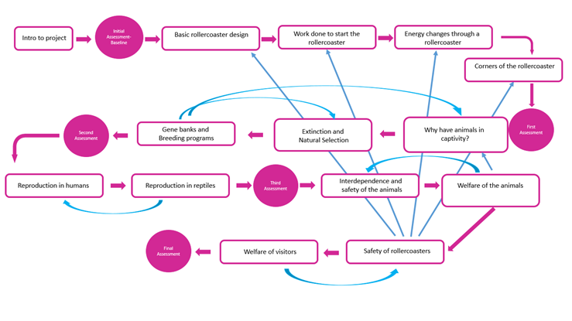

Mario Kart:
Project Title: Mario Kart
Project Intentions:
To understand the real world physics involved in racing cars.
To understand the effects of racing at high speeds on the human body
Knowledge | Scientific Skills
- Forces as pushes or pulls, arising from the interaction between objects  - Using force arrows in diagrams, adding forces in one dimension, balanced and unbalanced forces  - Friction between surfaces, associated with pushing things out of the way, resistance to motion of air and water  - Opposing forces and equilibrium  - Forces being needed to cause objects to stop or start moving, or to change their direction or speed  - Change depending on direction of force and its size  - Properties of ceramics, polymers and composites  - Combustion, thermal decomposition, oxidation and displacement reactions  - The effects of recreational drugs on behavior, health and life processes  - Content of a healthy human diet: carbs, lipids, proteins, vitamins, minerals, dietary fibre and water, and why each is needed | - Representing chemical reactions using formulae and using equations  - Chemical reactions as the rearrangement of atoms
Concrete links to the real world:

The majority of students will own a car in the future and understanding the physics of a car will help them to understand aspects of their car ownership. Understanding the link between driving and physical health will benefit students looking at a career in driving.
Suggested Learning Journey
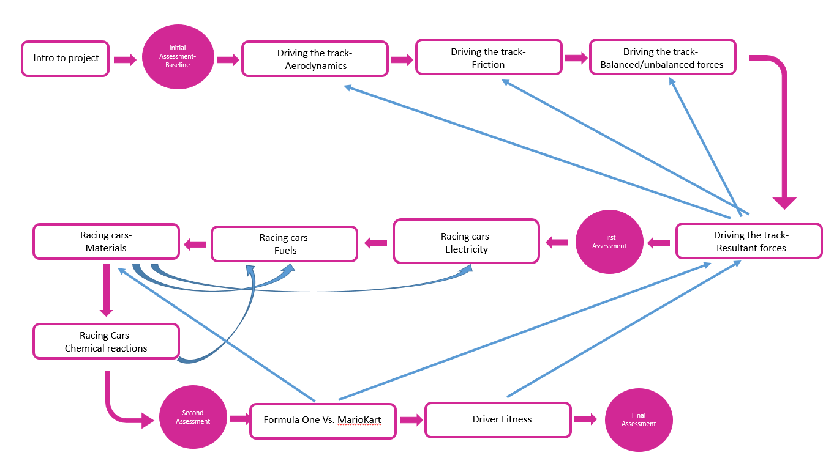

Robot Wars:

- Assessment
Overview of assessment structure:
Each project will follow a basic assessment model as follows-
Initial assessment | After a brief introduction to the project students will be formatively assessed to determine their prior level of understanding.  The data from this assessment will be used to determine the number of lessons dedicated to specific sections of the project. | Discussion based
First assessment | The first assessment determines their level of understanding of the first sections of the project only.  The data from this assessment will determine whether individual students move forward in the project or require strategic interventions. | Literacy/  Practical/  Presentation
Second assessment | The second assessment determines their level of understanding of the first and second sections of the project combined.  The data from this assessment will again determine whether individual students move forward in the project or require strategic interventions. | Literacy/  Practical/  Presentation
Final assessment | The final assessment will determine their level of understanding of the entire project.  This will not always be an exam style paper but could take the form of a presentation or the production of a physical piece of work. | Exam style

Retrieval Practise (blue arrow work):
Throughout the project retrieval points are highlighted by blue arrows on the project learning journey. At these points links can be made to previous learning and retrieval activities planned in to accommodate this.

Literacy Assessment Success Criteria:
Key Stage 3  Grade | Understanding Band | What it means
4 | Excellence | Can extend thinking and apply scientific ideas to situations not explicitly taught.  Ideas written in an organised and appropriate manner with minimal spelling and grammar errors.
3 | Secure | Can link and relate ideas.  Concepts written using good scientific terminology.  Ideas written in an organised and appropriate manner.
2 | Developing | Many ideas described but not in detail with no links between.  Concepts identified and discussed.
1 | Foundation | Single idea presented.  Recall produced as bullet points with no sentence structure present.

Practical Assessment Success Criteria:
Practical skills are developed and revisited within each topic but are not quantitatively assessed. For each practical experiment students complete they will RAG rate their confidence in the skills they demonstrated, as shown below:
I know the risks of an experiment
I know what the variables of my experiment are
I know what apparatus to use in an experiment.
I can write a method that works.
I can measure things correctly.
I can tell you what’s happening in an experiment.
I can show my results in a graph.
I can identify patterns in my data
I can explain what the results show.
This corresponds to a skills tracker where teachers will qualitatively track student progress. Over the course of a project students should be able to demonstrate each skill.

Grading and Understanding Bands:
Year | 1 | 2 | 3 | 4 | 5 | 6 | 7 | 8 | 9
7 | Knowledge: Basic, a few key words/facts with support  Understanding: Simple, demonstrating a lack of understanding of terms.  Communication: poorly organised, no specialist terms. | Knowledge: basic, relevant key words and facts.  Understanding: simple.  Communication: poorly organised. Has knowledge of keywords but can’t use them in a sentence. | Knowledge: basic information, some specialist terms used to describe processes – may lack accuracy  Can recall simple facts  Understanding: simple/basic  Communication: some organisation, keywords used but not necessarily accurately. | Knowledge: relevant and specialist terms, to describe processes  Understanding: simple/basic  Communication: some organisation,  Some use of scientific terms attempted – not always accurate  Attempts to use scientific idea to describe observations. | Knowledge: relevant and specialist terms to describe processes  Understanding: clear  Communication: some organisation, full sentences  Some use of specialist terms – may not always be accurate  Some detail given  Use scientific idea to describe observations. | Knowledge: relevant and specialist terms to EXPLAIN processes.  Ideas, models & theories linked to familiar situations.  Understanding: clear and supported by evidence and examples  Communication: clear and organised  Uses specialist terms  Use scientific idea to describe observations. | Knowledge: good – relevant and specialist terms EXPLAIN processes  Links attempted between Ideas, models & theories  Understanding: Detailed, with evidence and examples  Communication: clear and organised  Specialist terms used well  Use scientific idea to describe observations. | Knowledge: High – relevant and specialist terms EXPLAIN processes  Ideas, models & theories linked  Understanding: Very detailed, with evidence and examples  Explains challenging ideas linked to observations  and attempts are made to explain abstract concepts.  Explain experimental outcomes  Communication: clear and organised  Use scientific idea to describe observations.  Independently design an experiment with reliable data | Knowledge: High – relevant and specialist terms EXPLAIN processes  Ideas, models & theories linked to UNFAMILIAR SITUTATIONS  Understanding: very detailed, with evidence and examples  Can cogently explain challenging ideas linked to observations  Competently can explain abstract concepts from ALL AREAS and DISCUSS LINKS  Explain experimental outcomes  Communication: clear and organised, in logical sequence.  Use scientific idea to describe observations.  Design an experiment with reliable data
8 | Knowledge: Basic, a few key words/facts with support  Understanding: Simple  Communication: poorly organised, almost no specialist terms. | Knowledge: basic, relevant key words and facts.  Understanding: simple.  Communication: poorly organised. Difficulty using terms in a sentence. | Knowledge: basic information, some specialist terms used to describe processes – may lack accuracy  Can recall simple facts  Understanding: simple/basic  Communication: some organisation, some keywords used but not necessarily accurately. | Knowledge: relevant and specialist terms, to describe processes  Understanding: simple/basic  Communication: some organisation,  Some use of scientific terms attempted – not always accurate  Use scientific idea to describe observations. | Knowledge: Good - relevant and specialist terms to describe processes  Understanding: clear and drawing upon more than one scientific idea  Communication: some organisation  Some use of specialist terms – may not always be accurate  Some detail given  Use scientific idea to describe observations. | Knowledge: good - relevant and specialist terms to EXPLAIN processes.  Ideas, models & theories linked to familiar situations.  Understanding: clear and supported by evidence and examples  Communication: clear and organised  Uses specialist terms  Use scientific idea to describe observations. | Knowledge: High – relevant and specialist terms EXPLAIN processes  Links attempted between Ideas, models & theories  Understanding: Detailed, with evidence and examples  Communication: clear and organised  Use scientific idea to describe observations. | Knowledge: High – relevant and specialist terms EXPLAIN processes  Ideas, models & theories linked  Understanding: Detailed, with evidence and examples  Explain challenging ideas linked to observations  And attempts to explain abstract concepts.  Explain experimental outcomes  Communication: clear and organised  Use scientific idea to describe observations.  Independently design an experiment with reliable data | Knowledge: High – relevant and specialist terms EXPLAIN processes  Ideas, models & theories linked to UNFAMILIAR SITUTATIONS  Understanding: Detailed, with evidence and examples  Can cogently explain challenging ideas linked to observations  Explain abstract concepts from ALL AREAS and DISCUSS LINKS  Explain experimental outcomes  Communication: clear and organised, in logical sequence.  Use scientific idea to describe observations.  Design an experiment with reliable data
9 | Knowledge: Basic, a few key words/facts with support  Understanding: Simple  Communication: poorly organised, almost no specialist terms. | Knowledge: basic, relevant key words and facts.  Understanding: simple.  Communication: poorly organised | Knowledge: basic information, some specialist terms used to describe processes – may lack accuracy  Can recall simple facts  Understanding: simple/basic  Communication: answer has some structure and keywords are used | Knowledge: relevant and specialist terms, to describe processes  Understanding: simple/basic understanding tries to draw on multiple concepts, though not necessarily accurately.  Communication: some organisation,  Some use of scientific terms attempted – not always accurate  Use scientific idea to describe observations. | Knowledge: Good - relevant and specialist terms to EXPLAIN processes  Understanding: clear and using more than one scientific idea  Communication: some organisation  Some use of specialist terms – may not always be accurate  Some detail given  Use scientific idea to describe observations. | Knowledge: HIGH - relevant and specialist terms to EXPLAIN processes.  Ideas, models & theories linked to familiar situations.  Understanding: DETAILED and supported by evidence and examples  Communication: clear and organised  Uses specialist terms  Use scientific idea to describe observations. | Knowledge: High – relevant and specialist terms EXPLAIN processes  Ideas, models & theories linked  Understanding: Detailed, with evidence and examples  EXPLAIN challenging ideas linked to observations using key terminology  Communication: clear and organised  Use scientific idea to describe observations. | Knowledge: High – relevant and specialist terms EXPLAIN processes  Ideas, models & theories linked  Understanding: Detailed, with evidence and examples  Explain challenging ideas linked to observations  Explain ABSTRACT CONCEPTS  Explain experimental outcomes  Communication: clear and organised  Use scientific idea to describe observations.  Independently design an experiment with reliable data | Knowledge: High – relevant and specialist terms EXPLAIN processes  Ideas, models & theories linked to UNFAMILIAR SITUTATIONS  Understanding: Detailed, with evidence and examples  Explain challenging ideas linked to observations  Explain abstract concepts from ALL AREAS and DISCUSS LINKS  Explain experimental outcomes  Communication: clear and organised, in logical sequence.  Use scientific idea to describe observations.  Design an experiment with reliable data

Grade Boundaries for Exam Style Assessments:
Grade boundaries for KS3 exam style assessments are calculated the AQA GCSE single science grade boundaries (2024) as shown below. Grades will be based on students’ scores as a percentage of total marks available.
 |  |  | Mark | 9 | 8 | 7 | 6 | 5 | 4 | 3 | 2 | 1
Biology Tier F | 2024 | Jun | 200 | - | - | - | - | 132 | 113 | 82 | 52 | 22
Biology Tier H | 2024 | Jun | 200 | 141 | 126 | 112 | 90 | 69 | 48 | 37 | - | -

Throughout the year there will be three designated assessment points where all students will complete a SAT’s style paper. The data from these assessment points will be used to directly inform the whole school assessments and therefore whole school achievement tracking and student reports.
These points will be the penultimate week of; Autumn half term 1, Spring half term 1 and Summer half term 1. This will be the week before schoolwide data is due for entry and will be available ready for parents evenings following each half term holiday.

- Appendices
Appendix a.

Appendix b.

Appendix c.
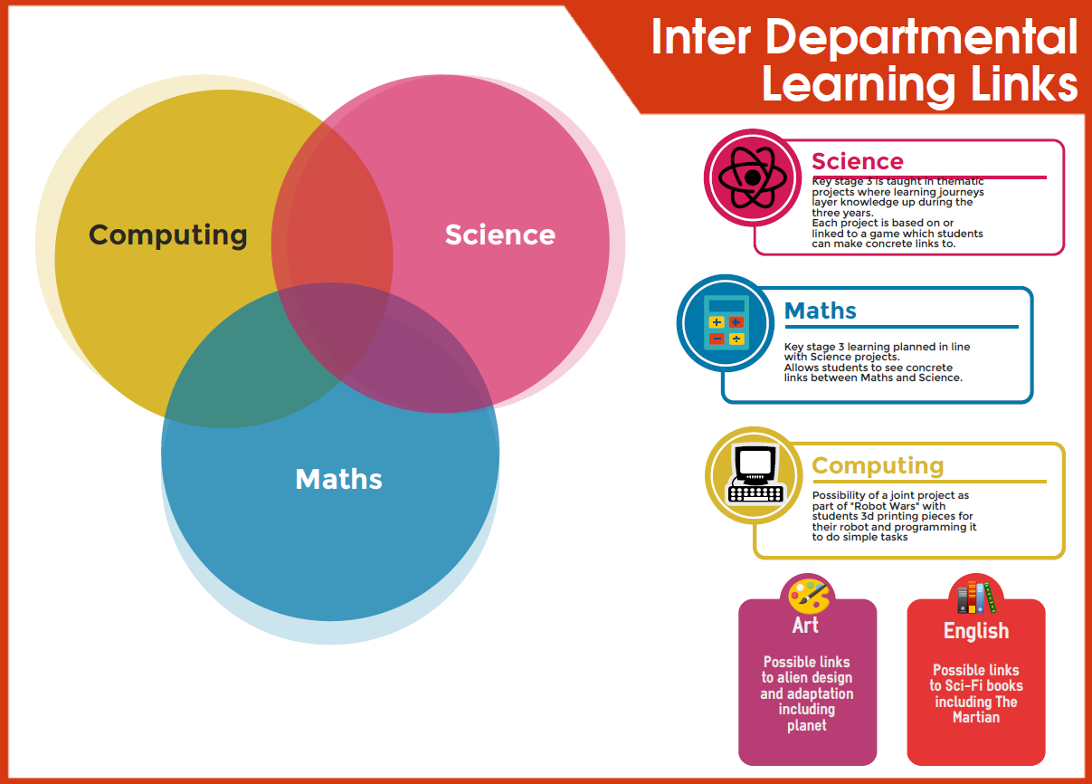

Appendix d.
Key Stage 3 Work Experience Links

Project | Work Experience Links
Cluedo | Police re finger printing, security, blood splatter
 | Security firm Night vision, IR
 | Alex Jeffrey’s re DNA
Space Invaders | Space centre
 | Institute of Physics (making an asteroid)
 | Leicester Astronomical Society
Pandemic
 | School nurse
Football Manager | Sean (fitness guru) nutrition
 | Brian about nutrition
 | Radio station ? Takeover
 | Loughborough Uni facilities
 | Police, Community support officers re drugs and alcohol
Sim City | Severn Trent Water
 | Magna Science Park
 | Chris to do virtual chat about wind farms etc.
 | New build v old houses, visit show home
Asteroids | Leicester Astronomical Society
 | Cadbury’s (changes in state)
Rollercoaster Tycoon | Fantasy Island / Twin Lakes / Alton Towers
 | Designer of rollercoasters
 | Visit zoo eg Twycross, keeper for a day
Mario Cart | Car show room
 | Parachute jump H&S
 | Forces people
 | Go Karting place/race car driver training
Robot Wars | Local robot wars club/thing
 | Karl for soundwaves
 | Blacksmith

Appendix e.

