How to install Outlook for emails on a Mobile

On the mobile phone:
Depending on what phone you have, open up the App store or Google Play.
1. Type in ‘Outlook’.
2. Click on ‘Install’
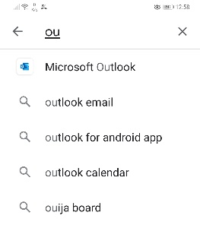

The Microsoft Outlook app should now be installed.
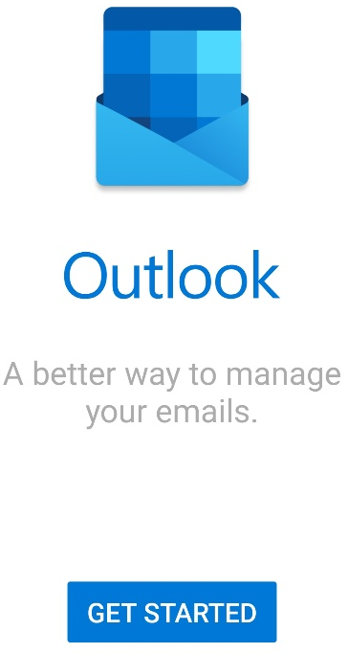
3. Insert your school email address.
4. It will ask for your password. Type it in.

Your emails should now be working through your phone.
